Practical 16 Polymorphism

- In your App class for your Animal project, you should have made an instance of a Dog and an instance of a Sealion and then called their respective toStrings. The toString methods should not only show the data properties but also the results from each String method. Include two more classes in your project a Tarzier and a Horse. Make the Horse class implement the Domesticated interface.
- Now create an example of polymorphism this is where the same method call has different behaviours depending on what object is calling it.
  - Make an arrayList of parent class Animal
  - Add in your already created Dog object
  - Add the the SeaLion object.
  - Create and add a Tarzier object.
  - Create and add a Horse object.
  - Loop through the array asking each animal to speak.
  - Loop through the array again asking each animal to show what work they do. Be careful here an Animal does not know about the work method so you will need to check whether the Animal is an instanceof Dog or Horse and if so cast the array element as a Dog or a Horse and call its work method. Any animal not an instanceof Dog or Horse should have printed out “does no useful work. Or can you check for an instanceof an interface?
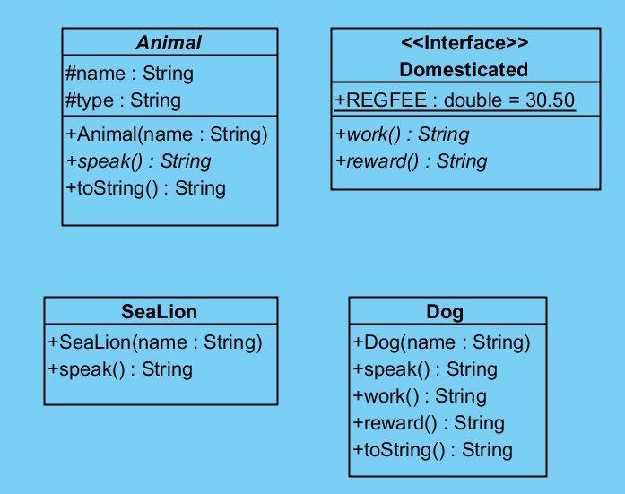

- Create an abstract class named NewspaperSubscriber with fields for a subscriber’s street address and the subscription rate. Include get and set methods for the subscriber’s street address, and get and set methods for the subscription rate. The set method for the rate is abstract. Include an equals() method that indicates that two Subscribers are equal if they have the same street address. Create child classes named SevenDaySubscriber, WeekdaySubscriber, and WeekendSubscriber. Each child class constructor sets the rate as follows: SevenDaySubscriber pay $4.50 per week, WeekdaySubscribers pay $3.50 per week, and WeekendSubscribers pay $2.00 per week. Each child class should include a toString() method that returns the street address, rate, and service type. Write a program named NewspaperApp that prompts the user for the subscriber’s street address and requested service and creates the appropriate object based on the service type. Do not allow the user to enter more than one subscription type for any given street address.

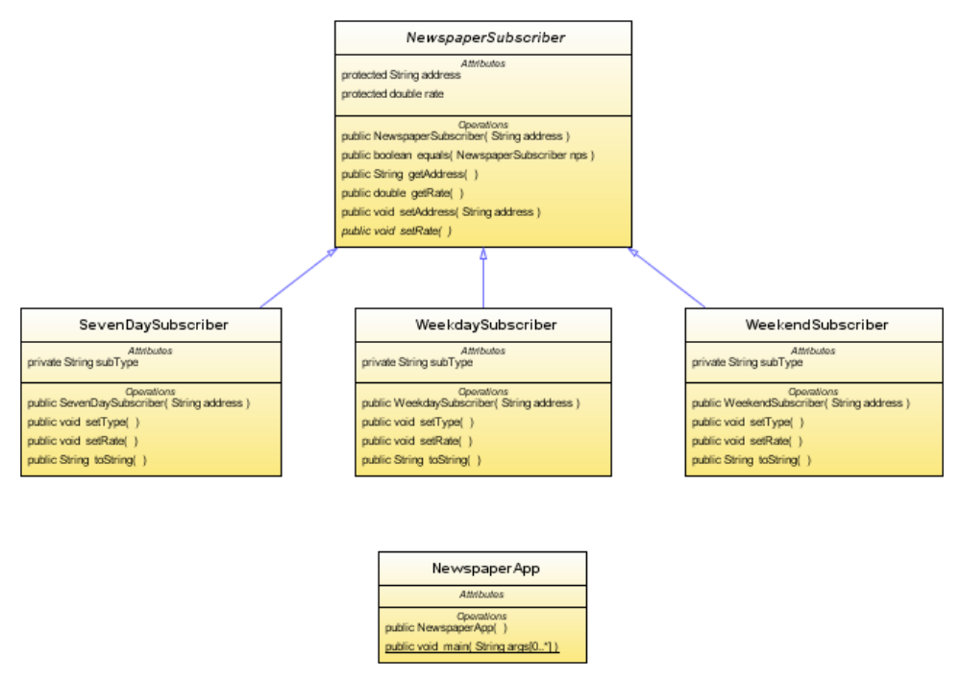

- Code up a new project called Pizza in it have a Java interface called PizzaConstants, in the interface code small, regular and large pizza prices, also have a constant for the company name. Declare a constant as
public static final int SMALL_DIAMETER = 12;
In the App class print out a message using these constants.
Declare the app class as:
public class PizzaApp implements PizzaConstants

- Assignment Data: Read your file and have it displaying in your console window.

